Experiment 7
UML Class, Use Case and Activity Diagrams for an Online Food Delivery System Using Umbrello
Aim
To design UML Class, Use Case, and Activity diagrams for an Online Food Delivery System using Umbrello.
Procedure
- Open Umbrello and create a new project.
- Create a Use Case Diagram and add actors such as Customer, Restaurant, Delivery Partner, and Admin.
- Add use cases such as Login, Browse Food, Place Order, Make Payment, Prepare Order, Deliver Order, and Manage Users.
- Connect the actors to their respective use cases.
- Create a Class Diagram and add classes such as Customer, Restaurant, FoodItem, Order, Payment, and DeliveryPartner.
- Add suitable attributes, methods, and relationships between the classes.
- Create an Activity Diagram to represent the food ordering process, from login and food selection to payment, order confirmation, and delivery.
- Save all three diagrams in Umbrello.

Output:
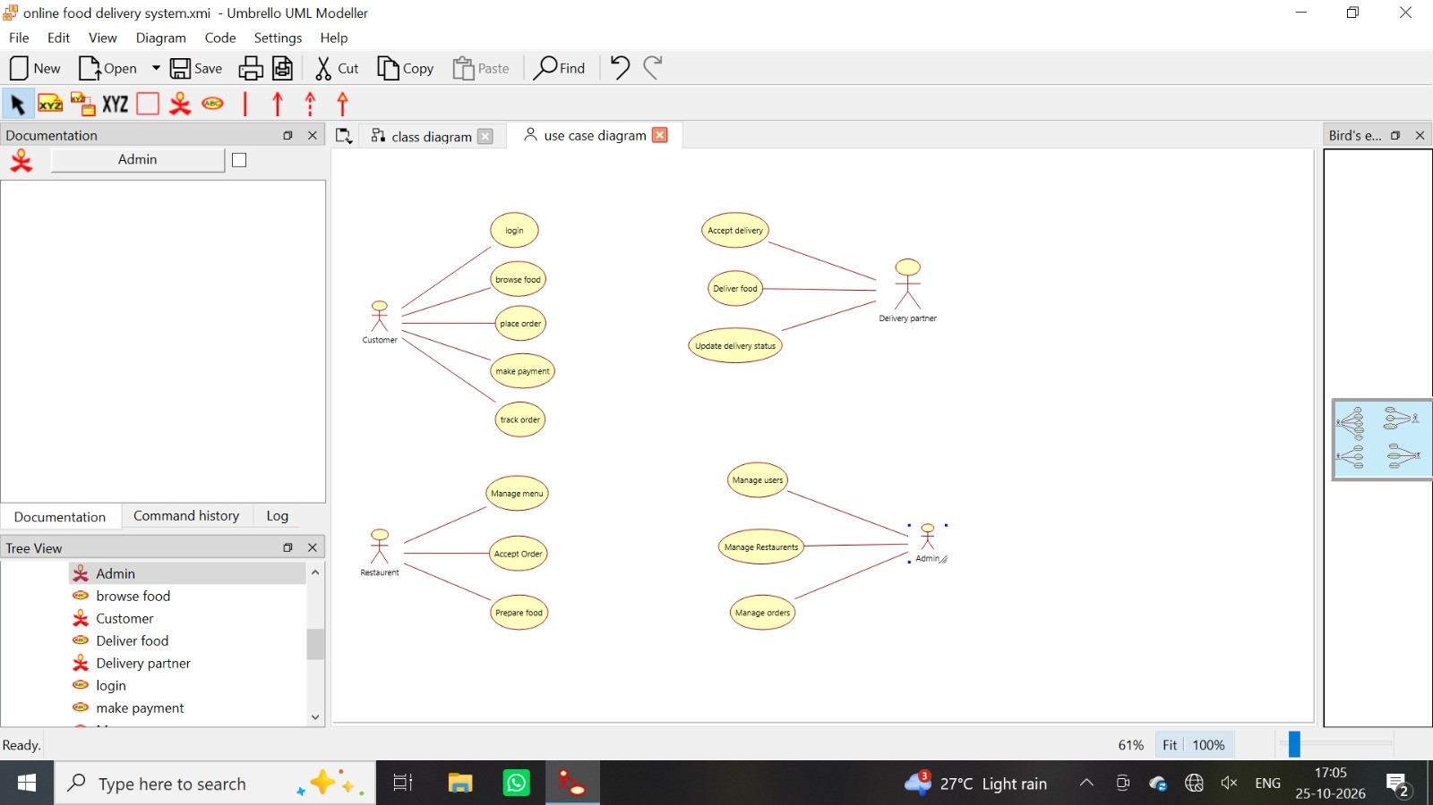
Result
The UML Class, Use Case, and Activity diagrams for the Online Food Delivery System were designed successfully using Umbrello.

